Nicholas Primiano

Problem 1

The drawing template is a higher level of organization. It is associated with a standard, for example ANSI or ISO. Once a template is chosen, a custom sheet format can be created. This would include thing like custom properties. Multiple sheet formats can be associated with a single drawing template. A particular drawing templated with a custom sheet format is called a custom drawing template.

Problem 2

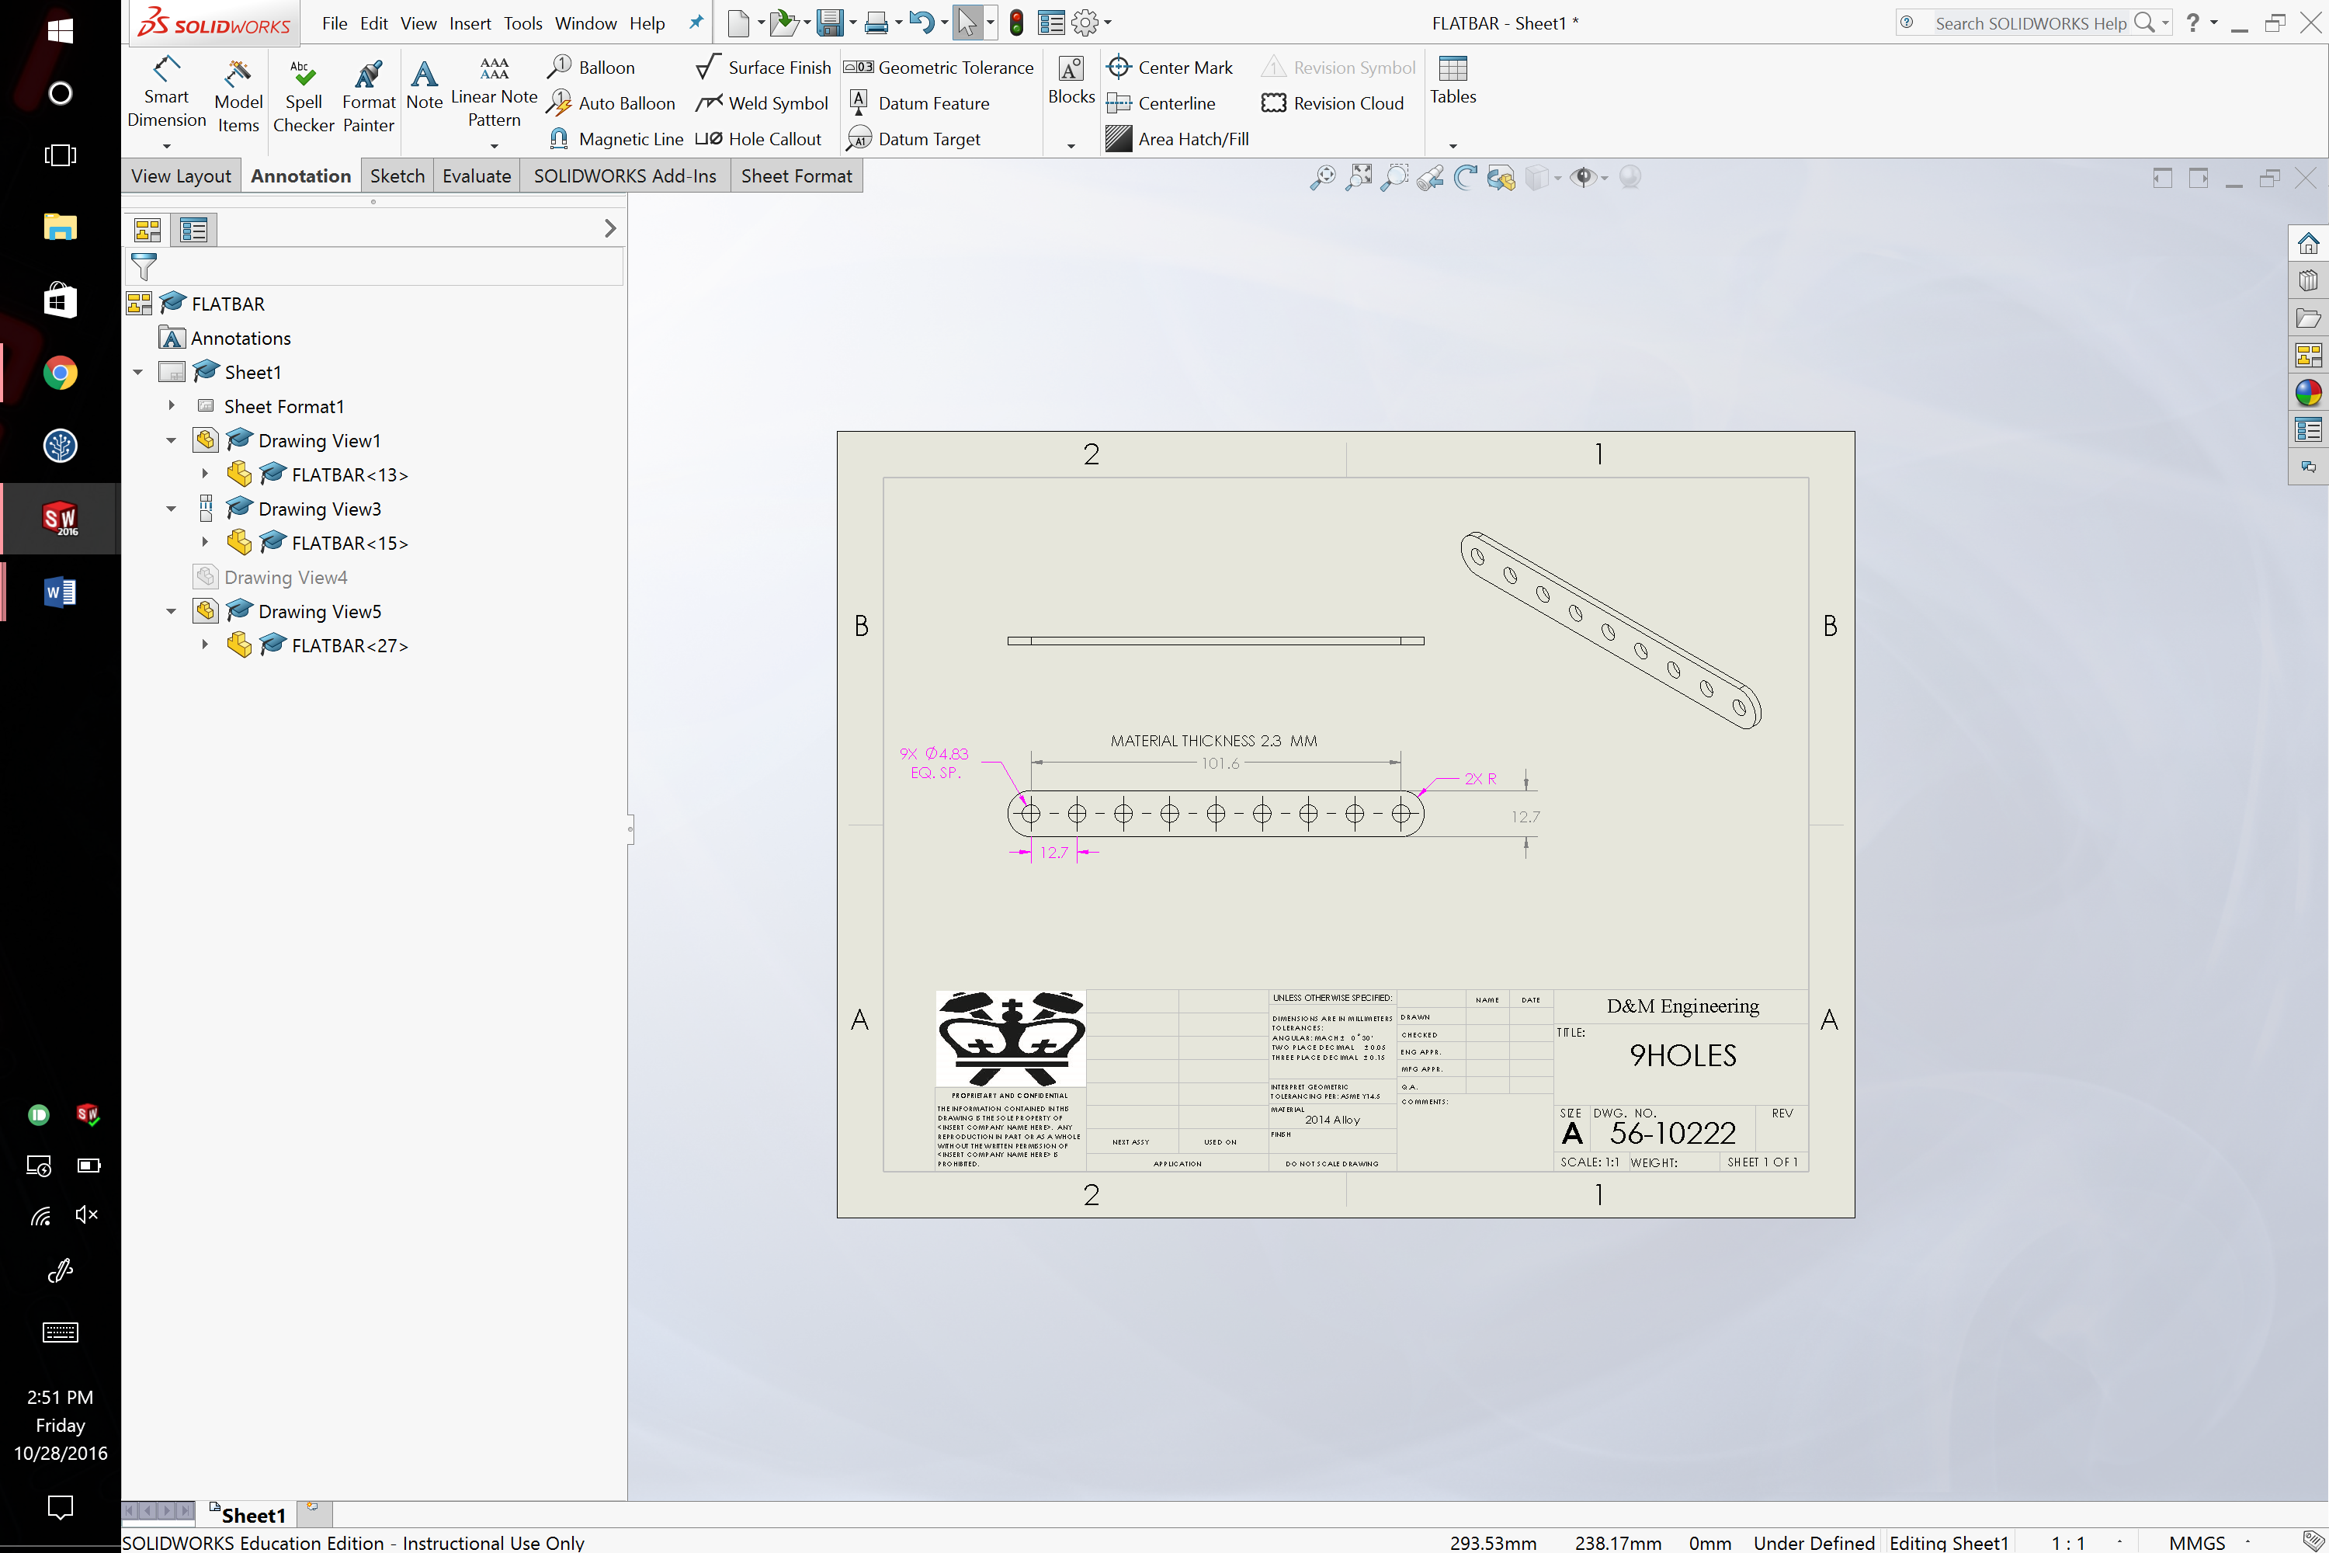

Problem 3

The origin was chosen as the center of the largest element of the part. The longest feature was created on the front view. The extrusion with the smaller hole was placed on the right plane so that it would show up (in full view) in the isometric view. It was nature to choose the top plane in the way shown below so that slanted and filleted feature can be shown. This orientation allows the most features of the part to be seen at once.

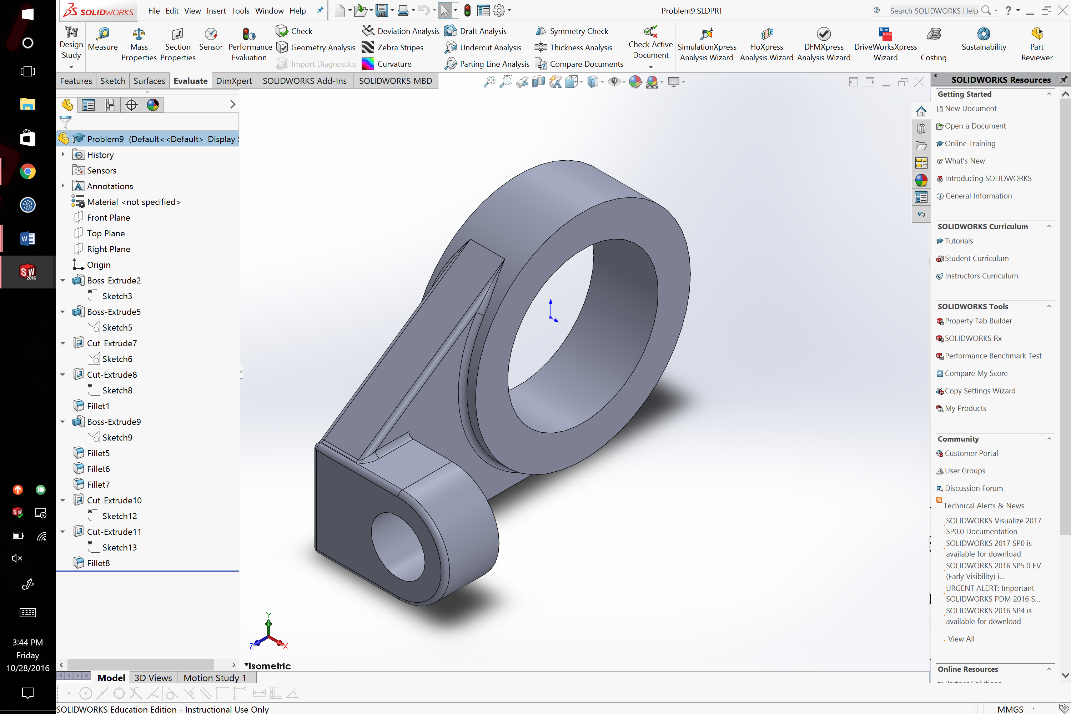

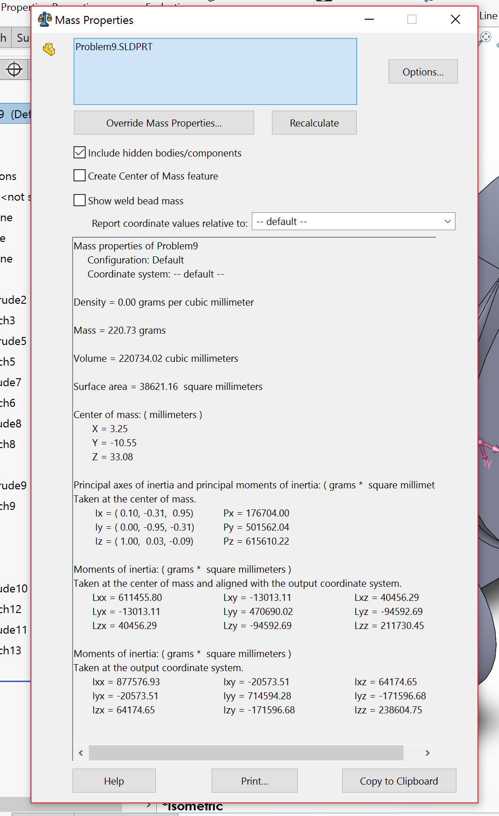

Problem 4

The front face was chosen to show as many features as possible. It shows all holes and extruded cuts. The top face was chosen such that the front extrude feature and its fillets can be easily seen in the isometric view. The part is symmetric about the Y-Z plane, so no choice was made for the right plane. Finally, the origin was chosen as the middle of the largest feature (circle) and the bottom center point of the rounded cut.

